TEC Community Leaders,
We are glad to announce that the application period for this year’s Gereke Fund is now open, and we are excited to share a new division of the fund, which will be used to award (1) the Gereke Grant and/or (2) the Enrichment Exchange.
The Enrichment Exchange is a new facet of the Gereke Fund, in which individuals may apply to travel and visit another TEC community with travel funds reimbursable up to $500. Just as Dorothy herself loved to travel, we want to share this joy with the TEC family at large, knowing that traveling benefits both the visitor and the host community.
As usual, any affiliated TEC Community may apply for the Gereke Grant to use for the benefit of TEC at the local level. The Gereke Grant may be used to purchase needed equipment, make repairs, advertise TEC, act as seed money for an event/fundraiser, defray the cost of group attendance at TEC Encounter, fund a workshop or community renewal experience… or any other worthy cause! Grants may be awarded for as little as $100 or up to $1,000 at the discretion of the selection team.
Applications for either/both are due by December 31, 2023. Please be sure to read the Information Sheets before applying. In January, a selection committee will review all complete and timely applications.
Only fully completed applications will be considered. Please help us to spread the word about this year’s Gereke Fund. We look forward to receiving a host of applications!
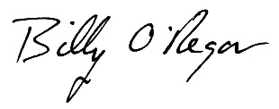
In Jesus,

Billy O’Regan
Executive Director

